Juan Daniel Suarez Amado

Jdsuarez623@misena.edu.co

2019

Short description

This application will teach you how to create your own website with HTML5, CSS3,  
BOOTSTRAP, MYSQL AND PHP.

user manual

Juan Daniel’s Virtual Programming Lab

Table of Contents

Application Description 2

Requirements 2

Downloading the application 2

Presentation Screens 3

Starting screen 4

Login and registration screen 4

Initial Menu Screen 5

Navigation menu 6

Menu options 7

Option courses 8

HTML5 course 8

CSS3 course 9

Bootstrap course 10

Php course 11

MySQL course 12

Option videos 13

Material option 14

Feedback option 15

Comment images 16

Option Have fun 17

Contact option 18

User Manual option 18

Logout option 19

**Application Description**

JD’s Virtual Programming Labis an application for smartphones with Android 5.1 lollipop or greater, the application teaches you how to create a website. The application is native, so connections are fast, and the interface is simplified for using it on the phone. The functions of the application are the teaching of 5 programming languages: HTML5, CSS3, BOOTSTRAP, MYSQL, PHP.

**Requirements**

The minimum requirements for the JDVPL application to work correctly are the following:

 1) Android operating system (5.1 or greater).

 2) Connectivity (3G, 4G. And / or WIFI).

**Downloading the application**

This application can be downloaded by accessing the link <https://play.google.com/store?hl=e>n directly from your Smartphone by going to the search engine and we write jdvpl, there it will appear as it is shown in the figure; Once you found and selected you will proceed to install it.

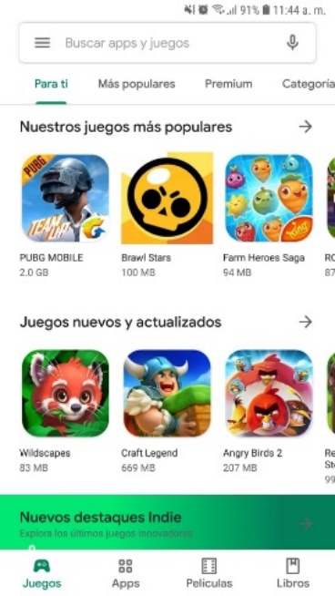 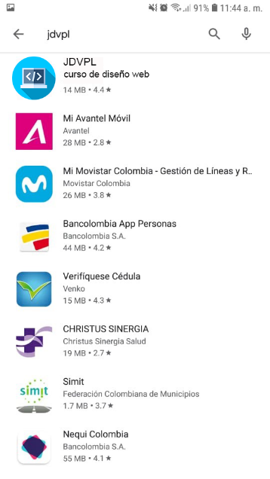 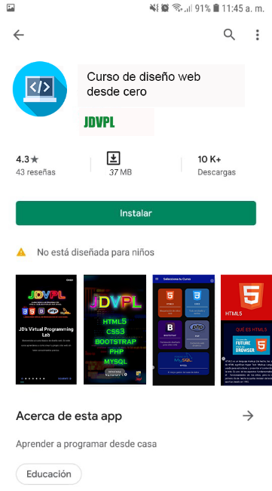

# **Presentation Screens**

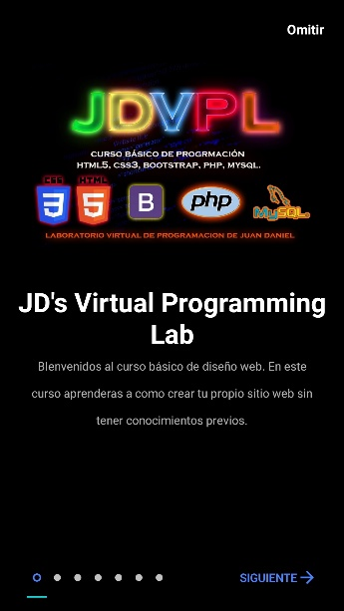 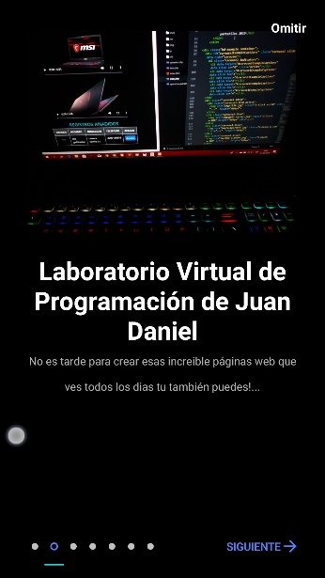 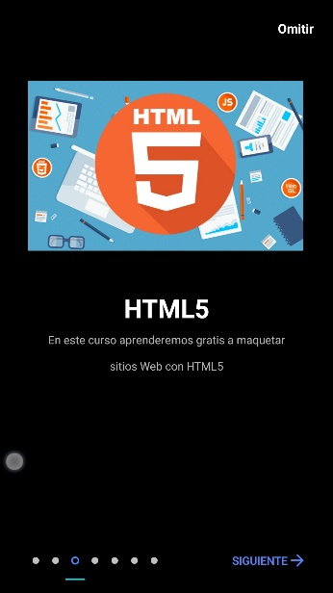 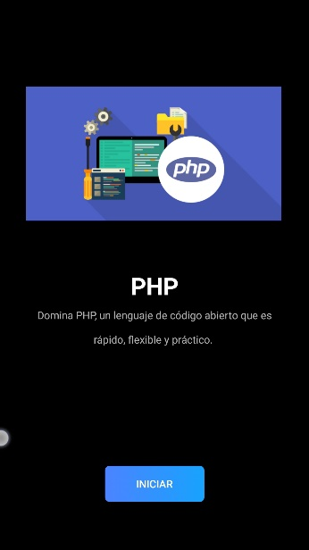

Figure 4

Figure 3

Figure 2

Figure 1

The first screen (Figure 1) will show you information about the application, as well as a brief description of the programming languages ​​contained in the jdvpl course. As we see in each screen you can skip or continue (Figure 2) if you want to know what the app will be about, once you finish the initial screens, you will get the start button (Figure 4) which will start the course web design; if you want to return to the initial screens you can do it by sliding backwards or by pressing on the small buttons as indicated in Figure 3.

# Observation: this presentation will appear only once, if you want it to appear again, you must delete the application data with the cache.

# **Starting screen**

Figure 1

After you have continued the presentation of the application, one screen will appear from now on every time you close the application. This screen contains the logo, the courses and the version.

# **Login and registration screen**

# 

Figure 4

Figure 3

Figure 2

Figure 1

After the first screen, the application will enter to the session screen (Figure 1), if you are not already registered, you must press the "**You are not registered**" button and there will be another screen (Figure 2), in which you must fill in the data to register, if you have already registered in another cell phone you will enter with the same email and password; also clicking on the application icon, it will go to the register screen (figure 3). With the icon that appears on the registration screen (Figure 4) you can choose a photo, which will go in your user profile, the picture will remain in the application every time you log in, for the other hand, if you already have an account, you must click on **“I already have Account”** and you will return to the Login Screen, where you can enter with the corresponding data.

The Login screen has two fields; one for the mail, with which you have registered and the other for the password, this can be seen with the icon eye.

On the Registration screen you have the fields of: First Name, Last Name, Email,

Password and Confirm Password you must complete all the fields to enter the application.

if you want to change the language you must press on the button that you can find in the top to the right and you select the corresponding language.

# **Initial Menu Screen**

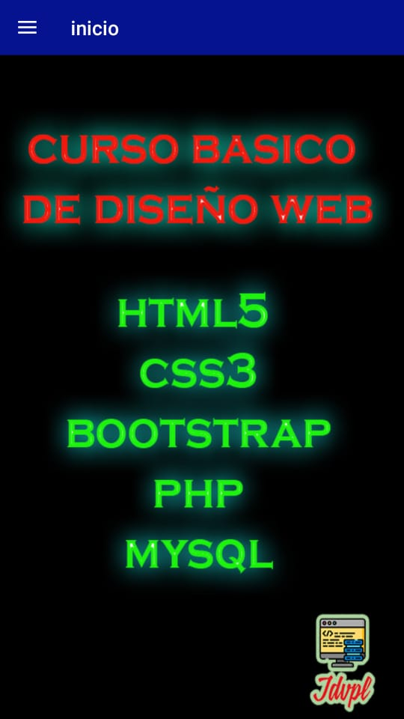

Figure 2

Figure 1

After you have registered or logged in, this screen will appear (Figure 1), which you have the information of: **“Curso basico de diseño web:** HTML5, CSS3, BOOTSTRAP, PHP, MYSQL” (Figure 1). At the top we will find the navigation icon that will then display a menu (Figure 2).

# **Navigation menu**

Figure 2

Figure 3

Figure 1

In this part we have the menu (Figure 1), it has the following options:

At the top we have the image, the email and the last name of the corresponding user (Figure 2).

At the bottom of the user's photo, you have the menu options, they have 8 options (Figure 3)

# **Menu options**

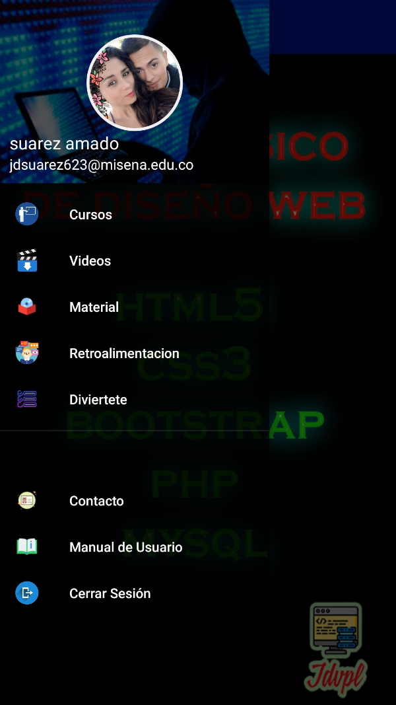 The first **"Courses"** in which are the 5 programming languages ​​that we are going to work on.

The second option **"Videos"** has all the videos related to the web design course.

The third option **"Material"** you will find the necessary software to carry out the course.

The fourth option “**Feedback"** you will find publications that will be made through screenshots or images in which you can publish or comment on these images.

The fifth option **"Have fun"** you can test yourself how much you have learned from the course.

The sixth option **"Contact"** you will find information of the person who made the application in case you have any questions.

The seventh option **"User Manual"** you can find the operation manual of the application.

The eighth option **"Log out"** is to exit the profile you are in and be able to start again or with another profile.

## **Option courses**

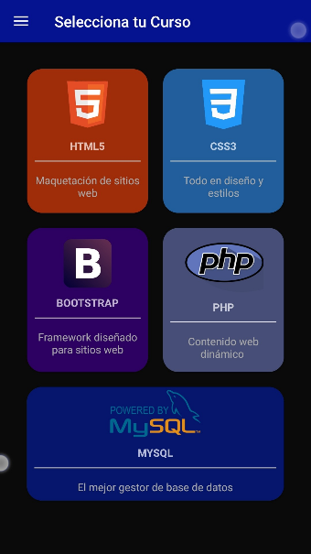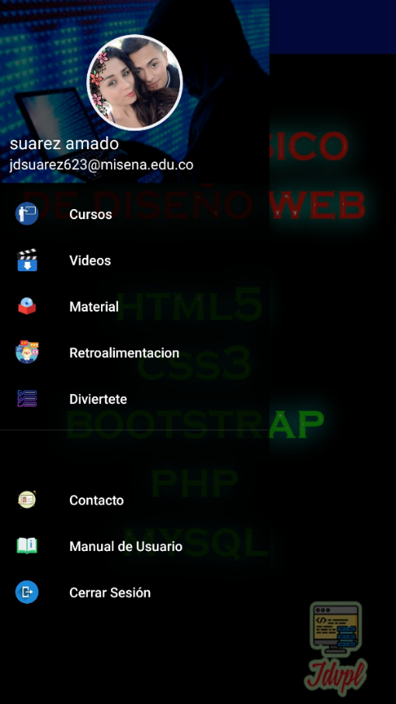

Figure 2

Figure 1

**In the "courses" option (Figure 1), you will find all the tutorials to perform for the design of a website, it consists of HTML5, CSS3, BOOTSTRAP, MYSQL, PHP. To access each Tutorial, you must press the icon of each programming language (Figure 2).**

### **HTML5 course**

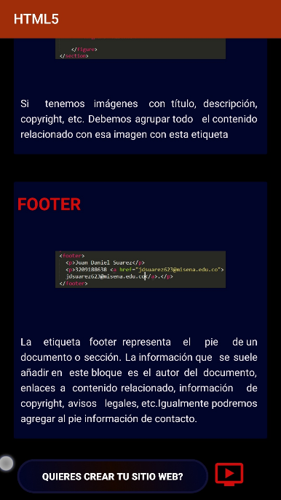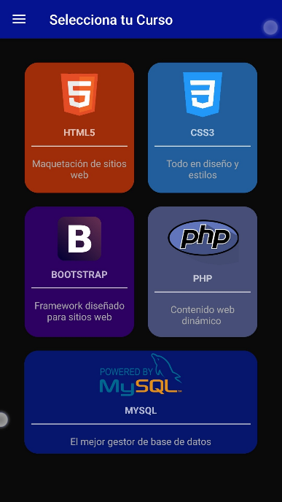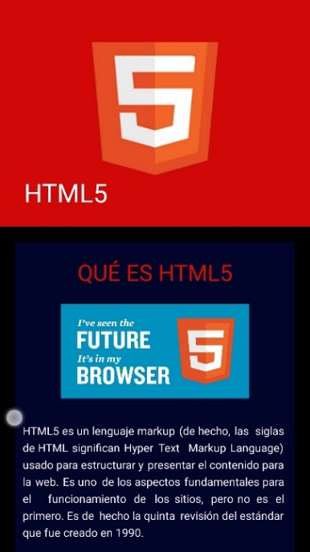

Figure 3

Figure 2

Figure 1

**After pressing the orange icon (Figure 1) you will enter to HTML5 programming course, it contains detailed information on this language (Figure 2); In addition to pressing any of the two buttons that you will find at the bottom of the HTML5 course (Figure 3) you will be able to see a video, this video you will learn how to make a website only with HTML5 language.**

### **CSS3 course**

Figure 2

Figure 3

Figure 1

**If you press the blue icon (Figure 1), you will enter to css3 course (Figure 2), you will have information about that course, at the bottom you will also find a video (Figure3) about how to give style to a website.**

### **Bootstrap course**

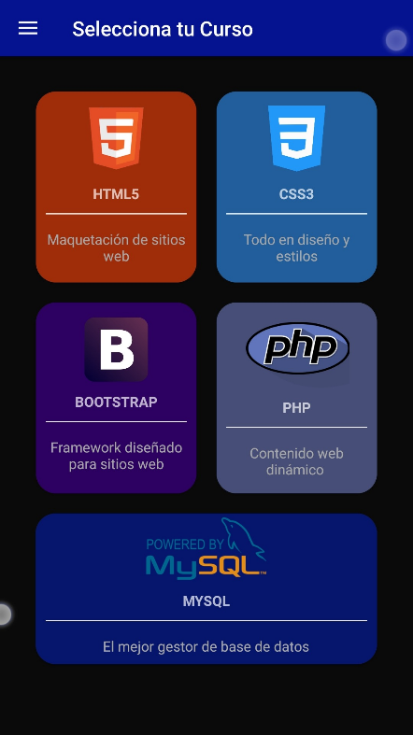

Figure 3

Figure 1

Figure 2

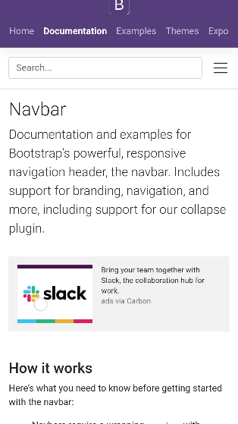

**If you want to learn Bootstrap you must press the Bootstrap box (Figure 1), then you will get information about that course (Figure 2); At the bottom (Figure 3) you can see a video showing how Bootstrap can be used, and you will also have access to the official website where you will find the course documentation in case you want to use other components (Figure 4).**

Figure 4

### **Php course**

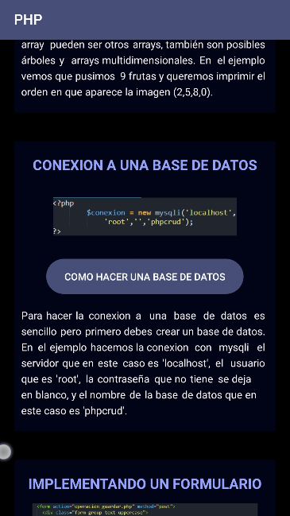

Figure 3

Figure 2

Figure 1

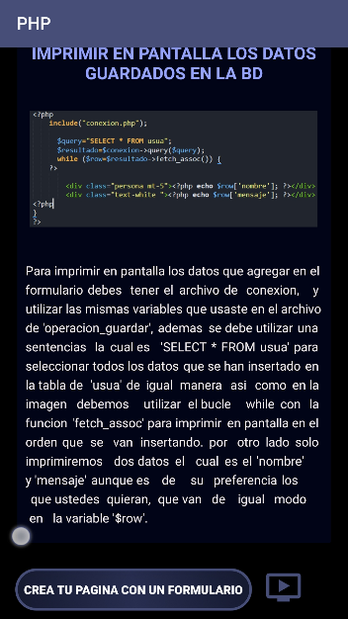

If you want to learn php, you must press the php box (Figure 1) and it will show you the basic course (Figure 2), you will also find images that were tested so that the users won’t have problems when they’re going to test it on some websites. You will also find a tutorial (Figure 3) about how to make a database if you do not have knowledge of mysql, finally at the bottom you can see a video (Figure 4) where I explain how to make a form by adding photos and texts.

Figure 4

### **MySQL course**

Figure 4

Figure 3

Figure 2

Figure 1

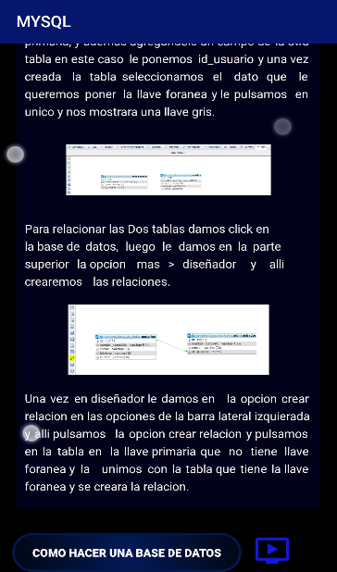 Finally, if you want to create or manage a database, you can access the MYSQL course (Figure 2) through the MySQL box (Figure 1), when you have accessed, you will find all the information about databases with MYSQL, you will also have to install a program (Figure 3), this program will work if you need to manage databases, also if you do not have knowledge of the data types of a database, you will find a website where you will find all types, by pressing the button as shown in Figure 4, on the other hand, you can watch a video tutorial by pressing the button at the bottom (Figure 5).

Figure 5

## **Option videos**

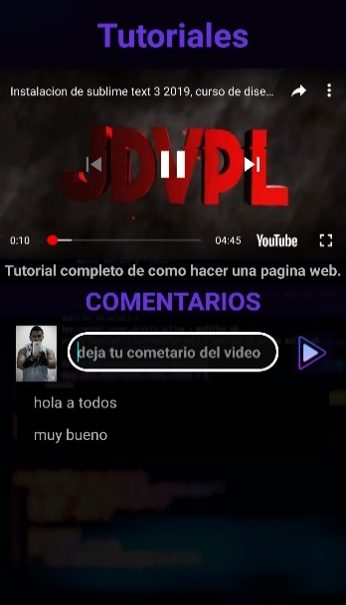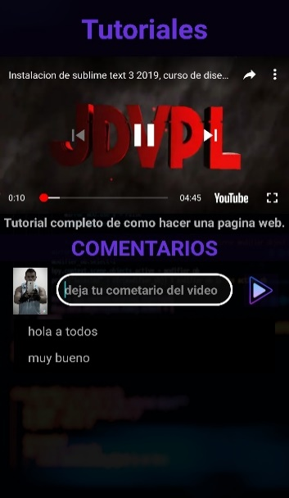

Figure 3

Figure 2

Figure 1

In the **video option** (Figure 1) you will find all the videos that the application contains, there are 7 videos in total and in the same way if you want to watch the next or the previous video, you just have to press the next or previous button (Figure 2). In the comments section (Figure 3) you can add or view comments from the tutorials.

## **Material option**

Figure 1

Figure 2

Figure 3

Figure 4

In **Material option** (Figure 1) you will find 2 videos (Figure 2) of installation of the software required to track the course, in addition to the icons of each software you will find the web pages of **Sublime Text 3** and **XAMPP**; for the other hand, in the plugins button (Figure 3) you will get the name of the plugins that I have installed in the tutorial, and also I left a web page of the most used plugins which you can access by pressing the web page button (Figure 4) .

## **Feedback option**

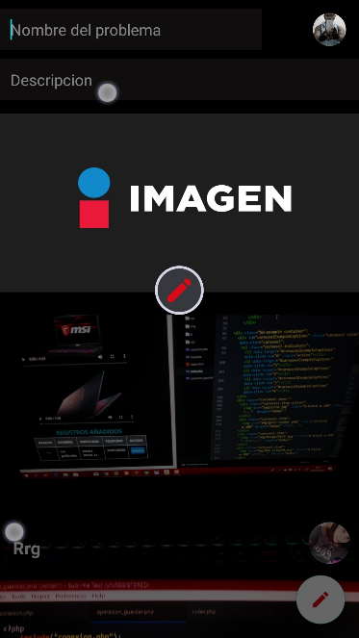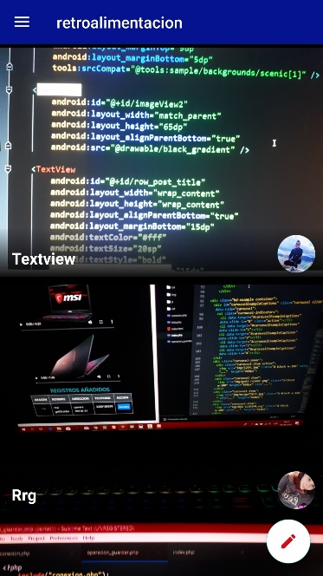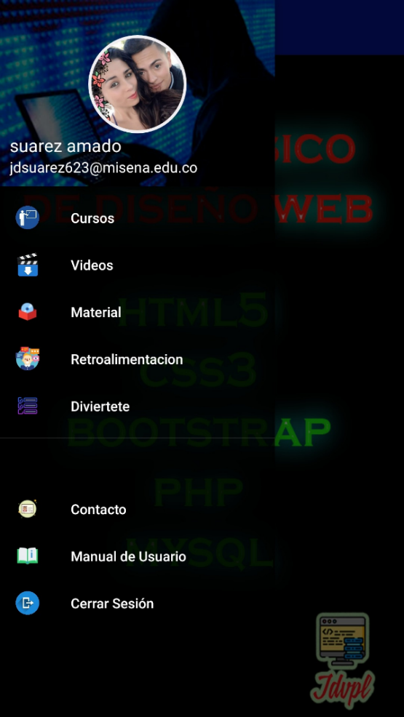

Figure 3

Figure 2

Figure 1

In the **feedback option** (Figure 1) you can see or add code images, if you want to add an image you must press the floating button (Figure 2) and you will get three fields in which you must fill them all (Figure 3), you must place the title of the problem, the Description and Image. After all the corresponding fields have been filled in, you must press the pencil button and it will be added correctly in the initial feedback screen in ascending order where the title you placed on the image and also the profile photo will appear as shown in the figure 2.

### **Comment images**

Figure 2

Figure 1

If you want to **comment or see** the description of the post, you must press the image that you want to comment (Figure 1), then a screen will appear where you can zoom the image, at the bottom of the image the image title will appear, the date of publication, the profile photo of the person who added it and below you can see the comments that people have made and you can also comment on the problem.

## **Option Have fun**

Figure 3

Figure 2

Figure 1

In the **Have Fun option** (Figure 1) you can do a little quiz about what you have learned in any of the 5 languages that the application has. As we can see you can select the type of programming language and the difficulty (Figure 2) so that you can test your knowledge of the subject, the record that you have accumulated the highest score is also 5. Once you have chosen the difficulty and type of language you will start and there will be a screen where you will be asked some questions, you must select the correct one, if it is correct you will accumulate the score, but be careful that there will only be 30 seconds to answer the question, if it is the correct one it will appear in green, Otherwise it will be red and a sound of agreement if it is correct or incorrect.

## **Contact option**

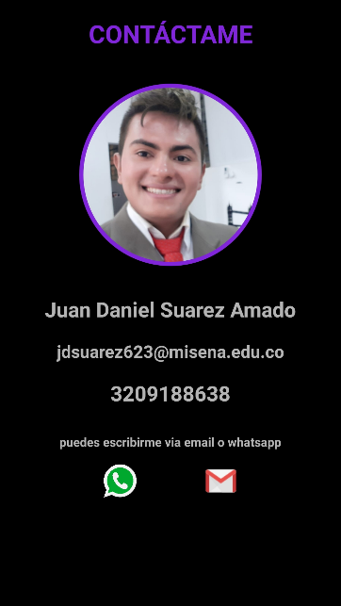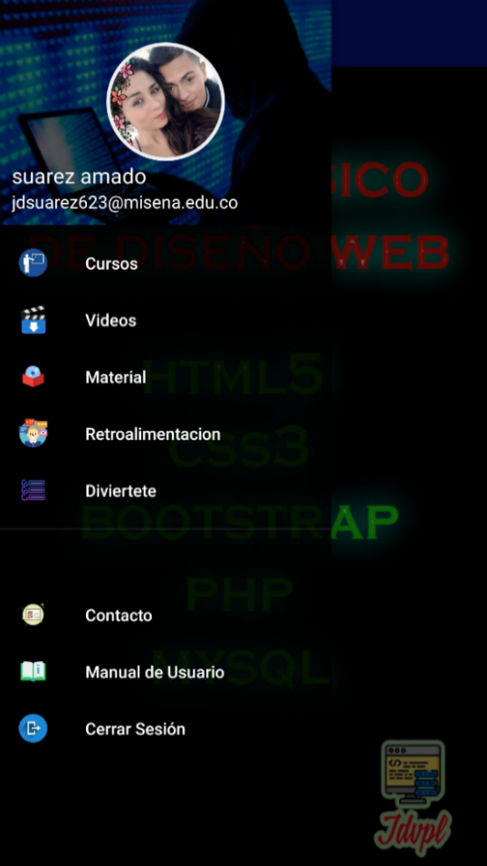

Figure

Tabla de contenido

**Escribir el título del capítulo (nivel 1)1**

Escribir el título del capítulo (nivel 2)2

Escribir el título del capítulo (nivel 3)3

**Escribir el título del capítulo (nivel 1)4**

Escribir el título del capítulo (nivel 2)5

Escribir el título del capítulo (nivel 3)6

2

Figure 1

In the **contact option** (Figure 1), you will find information about the author and creator of the application, at the bottom you can contact him through WhatsApp or Gmail if you have any concerns, suggestions or complaints by pressing the corresponding icons.

## **User Manual option**

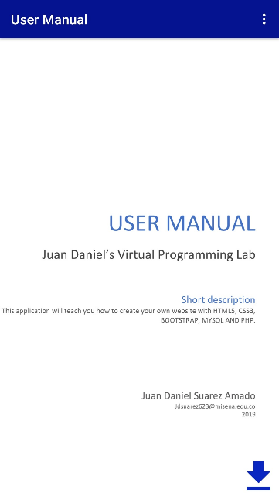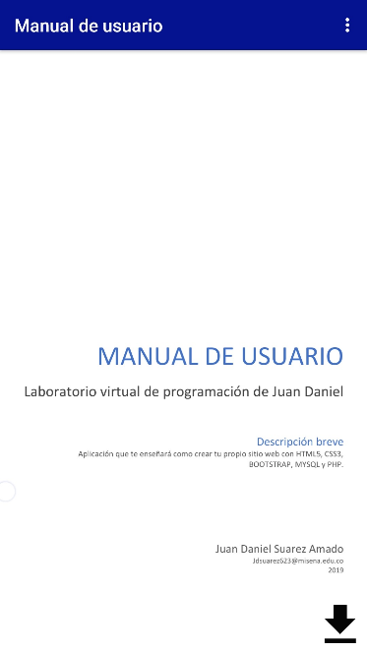

Figure 1

Figure 3

Figure 2

In the **user manual option** (Figure 1) you can find a guide on how the application is handled will be in the English version and in Spanish by pressing the icon found in the initial right part (Figure 2), you can also download the manual by pressing the download icon found in the lower right (Figure 3), but you must have internet to do so.

## **Logout option**

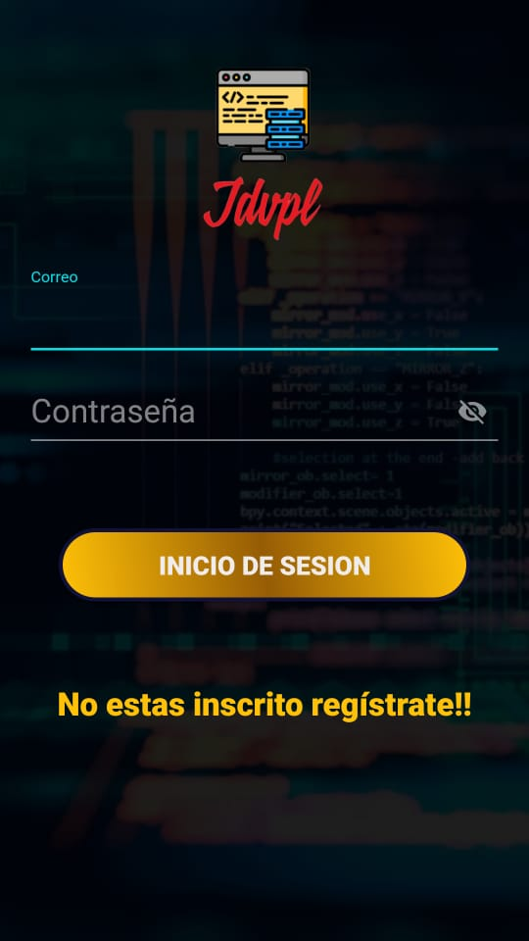****

Figure 1

Figure 2

In the option to log out (Figure 1) you can close the profile if you want to start again or want to start with another profile, once you have logged out you will return to the Login screen.

